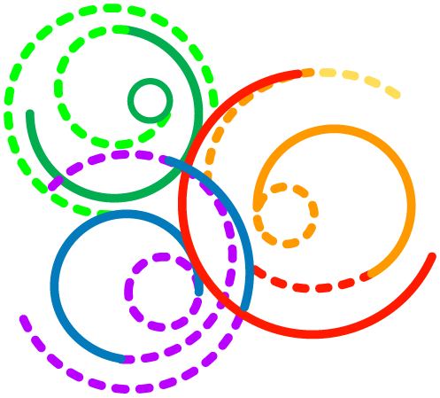
Daily Food Diary

Name: | Today’s Date:
Today Is: Monday Tuesday Wednesday Thursday Friday Saturday Sunday

DRINKS I HAD TODAY
Circle the number of drinks you had today, then check-off what kind of drink each was.
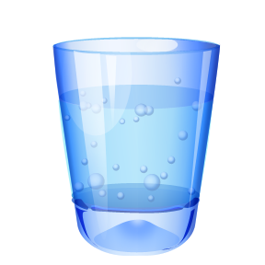
Caffeine  Milk  Sugar  Water | Caffeine  Milk  Sugar  Water | Caffeine  Milk  Sugar  Water | Caffeine  Milk  Sugar  Water | Caffeine  Milk  Sugar  Water | Caffeine  Milk  Sugar  Water | Caffeine  Milk  Sugar  Water | Caffeine  Milk  Sugar  Water

TODAY I ATE
Write down what you ate for each meal, or check off the kind of food you had at each meal.
 | 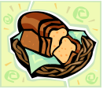  Bread, Pasta, Rice, Tortillas |   Cheese, Eggs, Meat, Tofu | 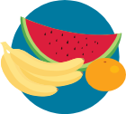  Fruit | 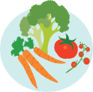  Vegetables
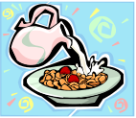
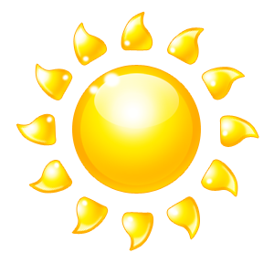
Breakfast
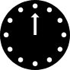
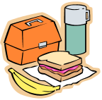
Lunch
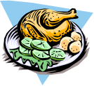

Dinner
Snacks
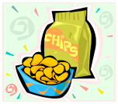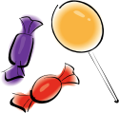
Updated: 04.08.11


Office of Developmental Primary Care  UCSF Department of Family and Community Medicine
500 Parnassus Avenue, MUE318, Box 0900  San Francisco, CA 94143
tel: (415) 476-4641  email: odpc@fcm.ucsf.edu  http://odpc.ucsf.edu

